Ambrogio Spinola — Response quality issues. First scan response opens mid-conversation instead of introducing the artifact, because prior conversation history is incorrectly passed to the vision-chat endpoint on initial detection. Fix: clear conversation history context on new artifact scan. Response length is also insufficient — tourist char limit is set to 400 but vLLM max_tokens=512 caps actual output at ~300 characters, making the two limits contradictory. Fix: raise max_tokens to 1024 in the vision-chat vLLM call.

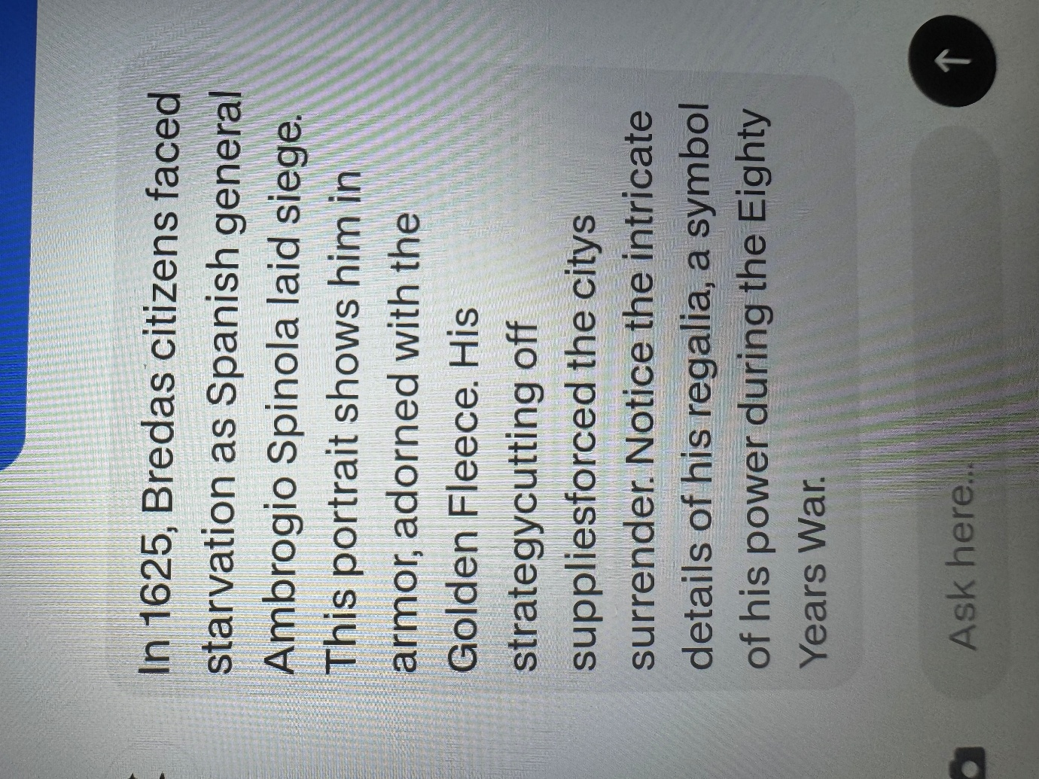

For this case it worked fine for the detection as the main reason for the failure was due to the retreivel of the model

Ambrogio Spinola (ST00629 / ST02230)
- Object type: 17th century engraving (Prent), black and white, oval portrait frame
- DB data: ✅ present, accurate, rich Dutch descriptions
- RAG retrieval: ✅ working correctly, returns relevant Spinola chunks
- CLIP detection: UNCERTAIN flag at 0.80 confidence — top 3 scores within 0.016 of each other (Albrecht, Spinola, Frederik Hendrik all visually near-identical at 1m distance)
- Root cause of confusion: All playtest artifacts are same-era portrait engravings — ruff collar, oval frame, black and white, small print on museum wall. CLIP-ViT-B-32 cannot reliably distinguish them at visitor phone distance
- LLM response: ✅ factually correct content but ❌ responded in English due to hardcoded system prompt (Always respond in English)
- Response was truncated at 245 chars due to tourist char limit cap (400 chars) — LLM stopped naturally under limit
- Image URLs confirmed accessible via Adlib hosting

